Vectors and Vector Spaces

1. Scalars and Vectors
Scalar: Magnitude only ( e.g., Temperature, Density, Concentration )
Vector: Magnitude + Direction ( e.g., Gravity Force, Velocity ) v , v
a = b if same direction and same length
Unit Vector: |a| = 1

2. Components of a Vector
We have two points P = ( 3, 1, 4 ) and Q = ( 1, − 2, 4 )
the vector PQ = [ − 2, − 3, 0 ].
v = [ v₁, v₂, v₃ ] = v₁ i + v₂ j + v₃ k
where v₁, v₂, and v₃ are components of v.
The length of v in Rectangular Cartesian Coordinate (RCC) system is given by
|v| =
e.g., PQ = - 2 i - 3 j , | PQ| =
Note that in RCC systems, i, j, and k are perpendicular (orthogonal) to each other.
If a = b then a₁ = b₁, a₂ = b₂, a₃ = b₃.

3. Addition and Multiplication
(1) Definition
Addition a + b
a = [a₁, a₂, a₃] ; b = [ b₁, b₂, b₃ ]
a + b = [a₁ + b₁ , a₂ + b₂ , a₃ + b₃ ]
Multiplication α a where α is a scalar
a = [ a₁, a₂, a₃ ]
α a = [ α a₁, α a₂, α a₃ ] and | α a | = | α | | a |

(2) Properties

Addition
a + b = b + a
(u + v) + w = u + (v + w)
a + 0 = a
a + (- a) = 0
| a | + | b | ≥ | a + b |

Multiplication
α ( a + b ) = α a + α b
( α + β ) a = α a + β a
α ( β a ) = ( α β ) a = α β a
1 a = a
0 a = 0
( − 1 ) a = − a

4. Vector Spaces

(1) Definition
For vector space R^{n} ,
a = [ a₁ , a₂ , a₃ , . . . , a_{n} ] ; b = [ b₁ , b₂ , b₃ , . . . , b_{n} ]
and a + b = [ a₁ + b₁ , a₂ + b₂ , . . . , a_{n} + b_{n} ]
α a = [ α a₁ , α a₂ , α a₃ , . . . , α a_{n} ]
R³ : a = [ a₁ , a₂ , a₃ ]

(2) Properties
Addition
a + b = b + a
( u + v ) + w = u + ( v + w )
a + 0 = a Definition of 0
( a ) + ( - a ) = 0 Definition of - a
Multiplication
α ( a + b ) = α a + α b
( α + β ) a = α a + β a
α ( β a ) = ( α β ) a = α β a
1 a = a

(3) Linear Independence and Dependence

Linear Combination
c₁ a₁ + c₂ a₂ + c₃ a₃ + . . . + c_{m} a_{m}
e.g., [ - 5, 11 ] is a linear combination of [ 2 , 4 ] and [ 3 , - 1 ].
Linear Independence
If the only solution of the equation
c₁ a₁ + c₂ a₂ + c₃ a₃ + . . . + c_{m} a_{m} = 0
is c₁ = c₂ = c₃ = . . . = c_{m} = 0
then a₁, a₂, . . . , a_{m} are linearly independent.

Linear Dependence
If there exist m scalars c₁ , c₂, . . . , c_{m} not all zero such that
c₁ a₁ + c₂ a₂ + c₃ a₃ + . . . + c_{m} a_{m} = 0
then a₁, a₂, . . . , a_{m} are linearly dependent.

[Example] i = [ 1 , 0 , 0 ] ; j = [ 0 , 1 , 0 ] ; k = [ 0 , 0 , 1 ]
⇒ i , j , and k are linearly independent.
[Example] a = [ - 7 , 7 , 7 ] ; b = [ - 1 , 2 , 4 ] ; c = [ 5 , - 3 , 1 ]
Are a , b , c linearly dependent or independent?

Dimension n
The maximum number of linearly independent vectors is the dimension of the vector space.
e.g., v₁, v₂, . . . , v_{n} are linearly independent
and v = c₁ v₁ + c₂ v₂ + . . . + c_{n} v_{n}
for every vector v in the vector space, then
[ v₁, v₂, . . . , v_{n} ]
form a basis for the vector space.
[Exercise] Show that [ 1 , 2 ] and [ - 1 , 1 ] form a basis for R².
[Hint] Need to prove two things:
(1) [ 1 , 2 ] and [ - 1 , 1 ] are linearly independent.
(2) Any vector [ x , y ] in R² can be represented by the linear combinations of [ 1 , 2 ] and [ - 1 , 1 ].

5. Inner Product (Dot Product, Scalar Product)

Definition
a•b = |a| |b| cos γ
where γ is the angle between a and b, 0 ≤ γ ≤ π
If a•b = 0, we have one of the following: (i). a = 0, (ii). b = 0, (iii). a ⊥ b ( orthogonal or perpendicular to each other ).

[Example] i•i = 1 ; i•j = 0 ; i•k = 0
j•i = 0 ; j•j = 1 ; j•k = 0
k•i = 0 ; k•j = 0 ; k•k = 1

[Example] a = a₁ i + a₂ j + a₃ k ; b = b₁ i + b₂ j + b₃ k
a•b = a₁ b₁ + a₂ b₂ + a₃ b₃

[Exercise] u = 2 i - 3 j - 4k ; v = - 3 i + j - 2 k
u•v = ?

Properties

a•b = b•a
( a + b ) • c = a•c + b•c
( α a ) • b = α ( a • b )
| a | =
cos γ =
| a•b | ≤ |a||b| Schwarz Inequality

[Exercise] Let v be a nonzero vector, then for any other nonzero vector u, show that
w = u −
is orthogonal to v.

Projection – a vector
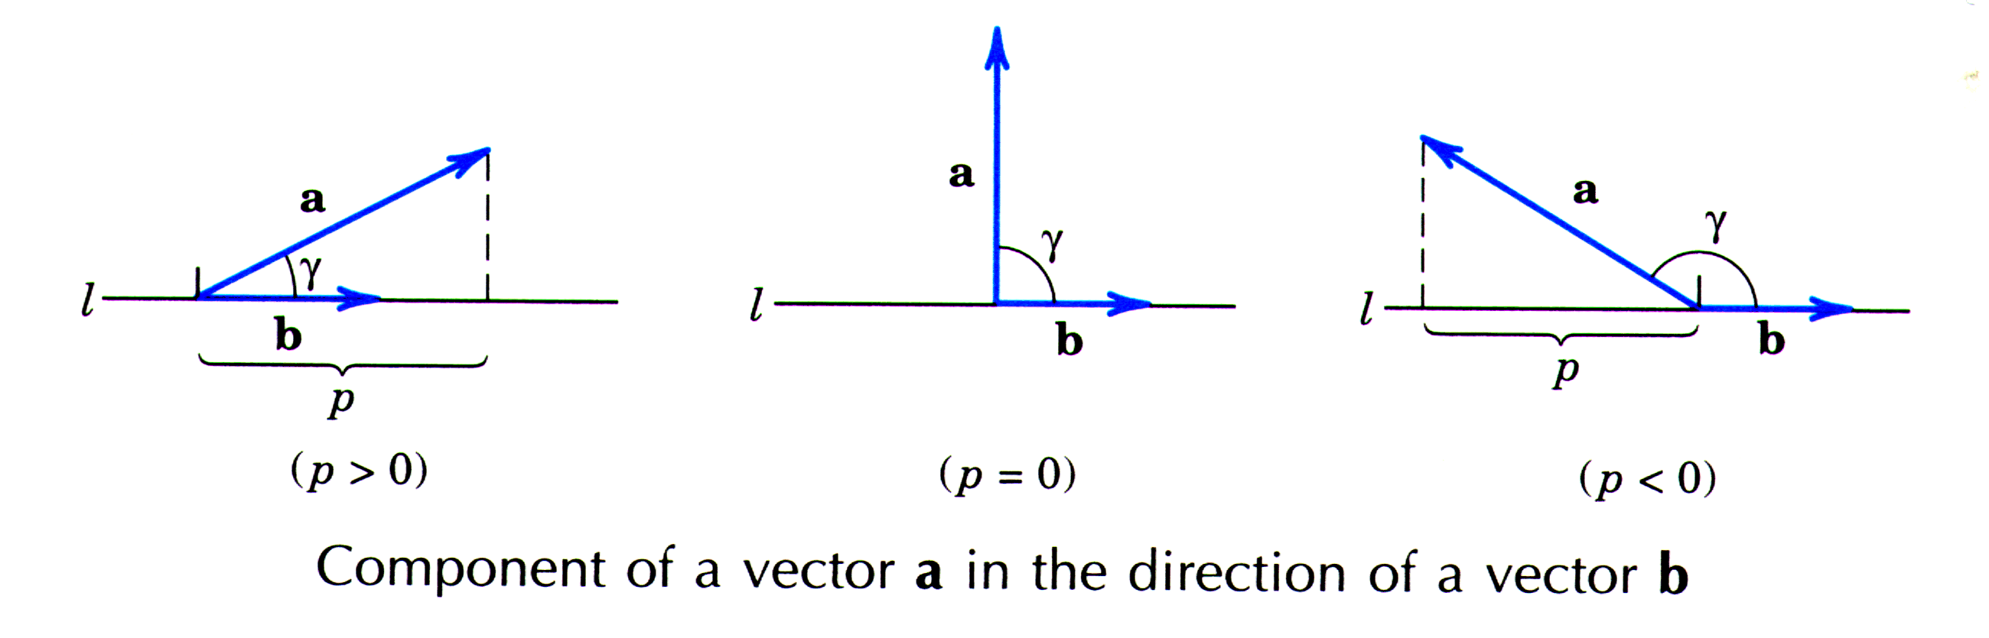
Projection of a onto b (a vector in the direction of b) :
Unit vector in the direction of b :
=|p| = |a| cos γ = =
= component of a in the direction b.
⇒ p = |a| cos γ =

[Exercise] Let a = 2 i + 3 j + k , b = i + 2 j − 6 k
Find the projection of a onto b.
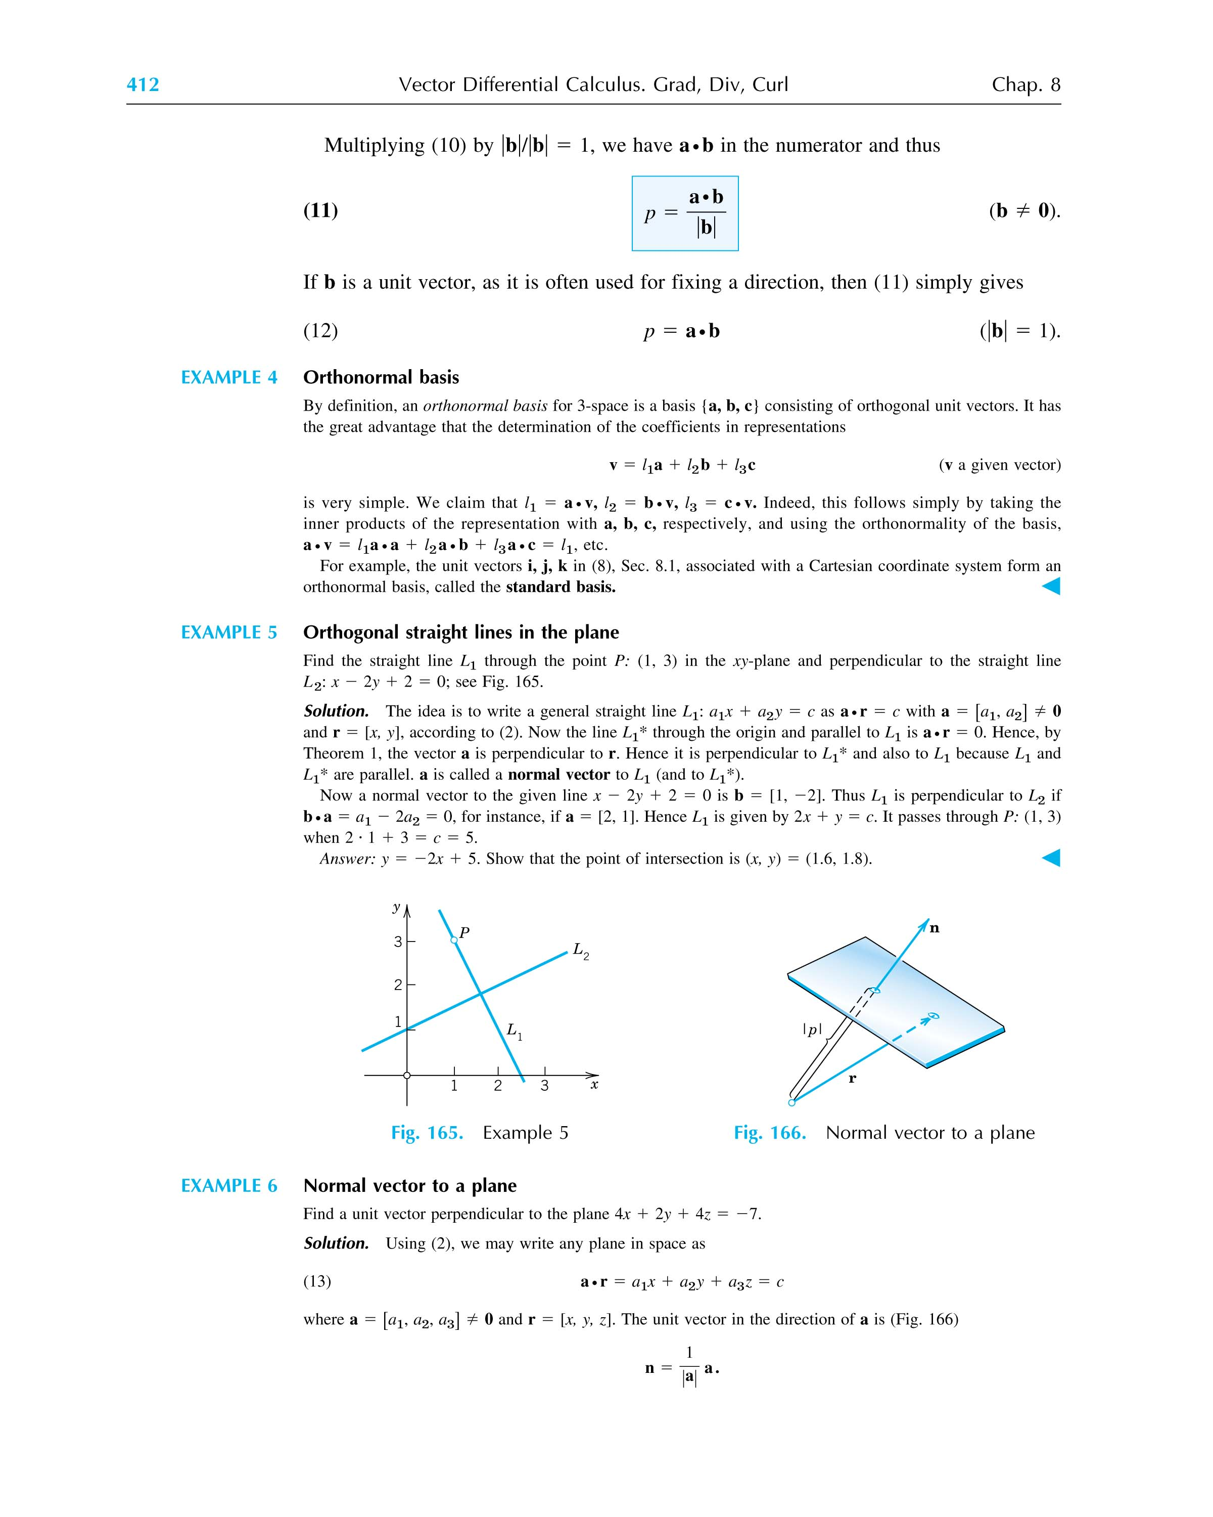

6. Vector Product (Cross Product) a × b
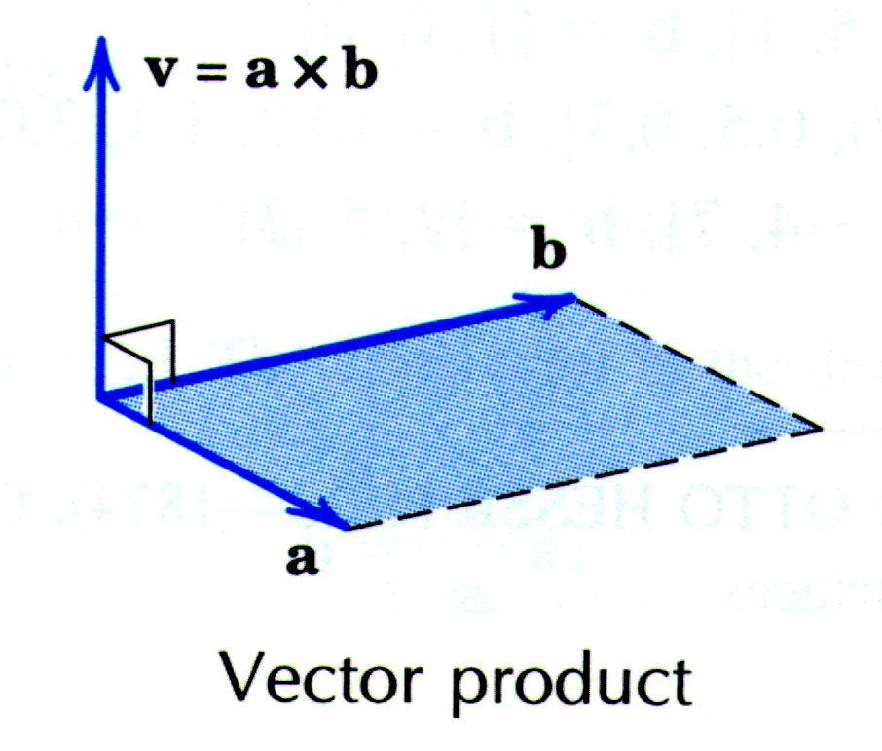
Definition
Magnitude: |a × b| = |a||b| sin γ
Direction: a × b ⊥ a , a × b ⊥ b , follows right-handed rule.
a × b = 0 if

Properties
a × 0 = 0 × a = 0
a × b = - ( b × a ) (not commutative!)
α ( a × b ) = ( α a ) × b
a × ( b + c ) = a × b + a × c
( a + b ) × c = a × c + b × c
( a × b ) × c ≠ a × ( b × c ) (not associative! See page 417 for proof.)

Components in RCC
i × i = 0 i × j = k i × k = - j
j × i = - k j × j = 0 j × k = i
k × i = j k × j = - i k × k = 0
and a × b = ( a₁ i + a₂ j + a₃ k ) × ( b₁ i + b₂ j + b₃ k )
= a₁ b₁ i × i + a₁ b₂ i × j + . . .
= ( a₂ b₃ - a₃ b₂ ) i + ( a₃ b₁ - a₁ b₃ ) j + ( a₁ b₂ - a₂ b₁ ) k
=

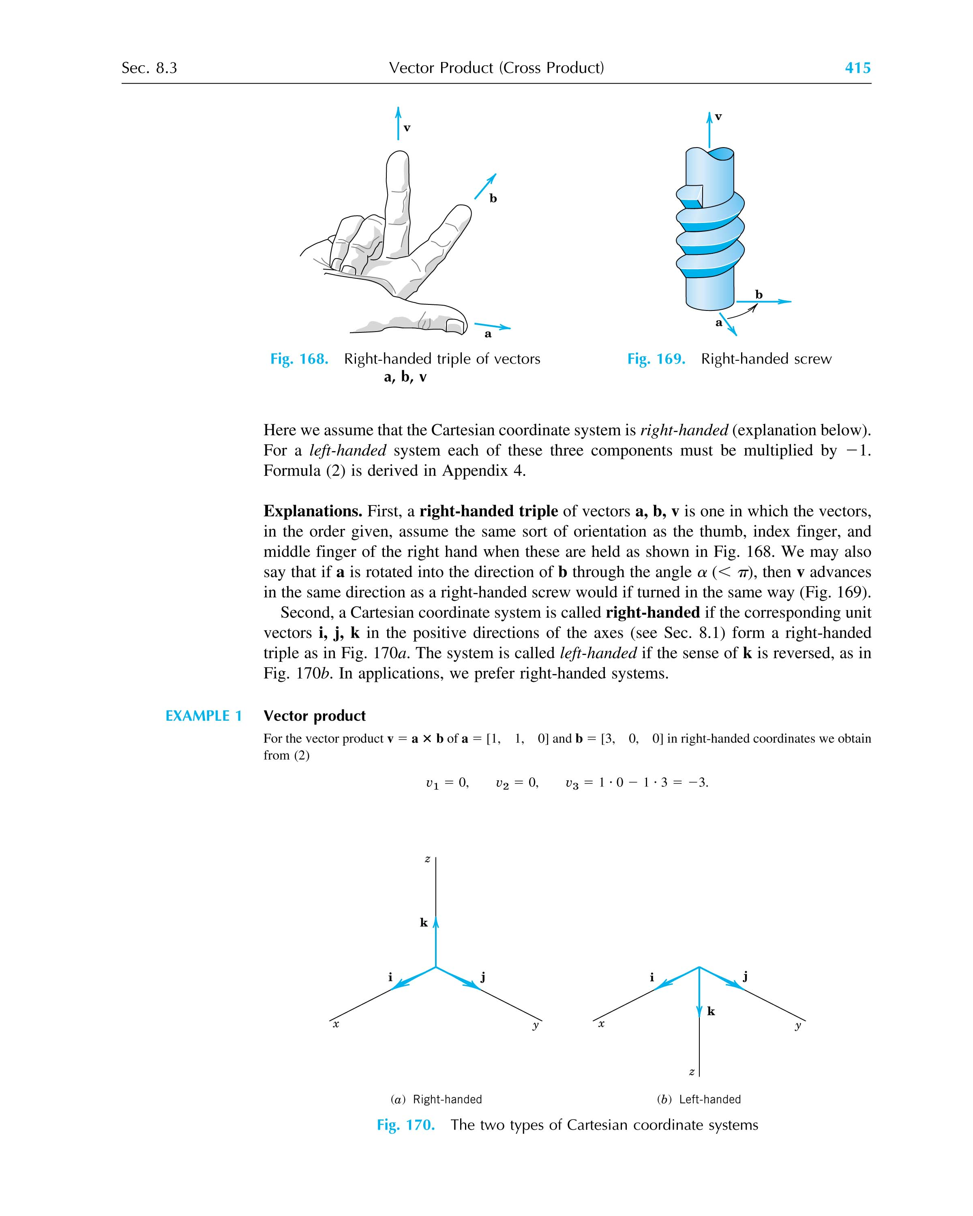

[Example] Moment of a force
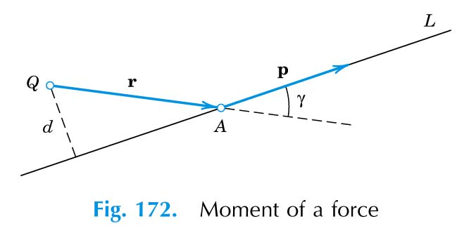
Here, the vector m is called the moment vector of p about Q. Its magnitude is the moment of this force about point Q. If , its direction is that of the axis of the rotation about Q that p has the tendency to produce.
[Example] Velocity of a rotating body
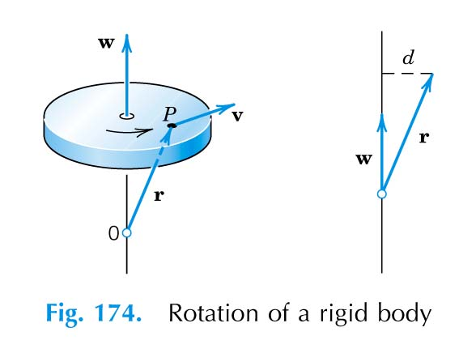
The magnitude of is equal to the angular velocity of the rotation, i.e., the linear (tangential) speed of point P divided by its distance d from the axis of rotation.

7. Scalar Triple Product: a • ( b × c ) or ( a b c )
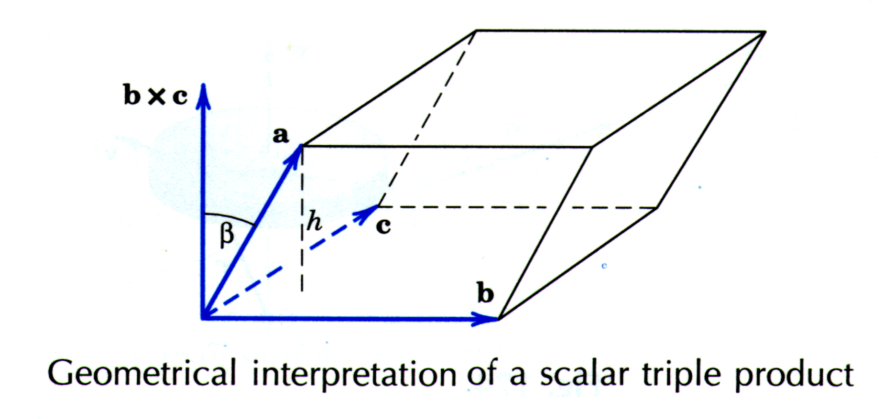
Values of a • ( b × c )
a • ( b × c ) =
Geometric Meaning

Properties
(1) a • ( b × c ) = ( a × b ) • c
(2) a • ( a × b ) = 0 ; b • ( a × b ) = 0
(3) a • ( b × c ) = 0 for a ≠ 0, b ≠ 0, c ≠ 0 if and only if a, b, and c are coplanar.

8. Some Important Identities
a × ( b × c ) = ( a • c ) b - ( a • b ) c
( a × b ) • (c × d ) = ( a • c ) ( b • d) - ( a • d ) ( b • c)
( a × b ) × (c × d ) = [ a • ( b × d ) ] c - [ a • ( b × c ) ] d

